Your work will be evaluated for functionality and design pattern.

Node Project setting

Based on the following screenshot and answer the next 2 questions below

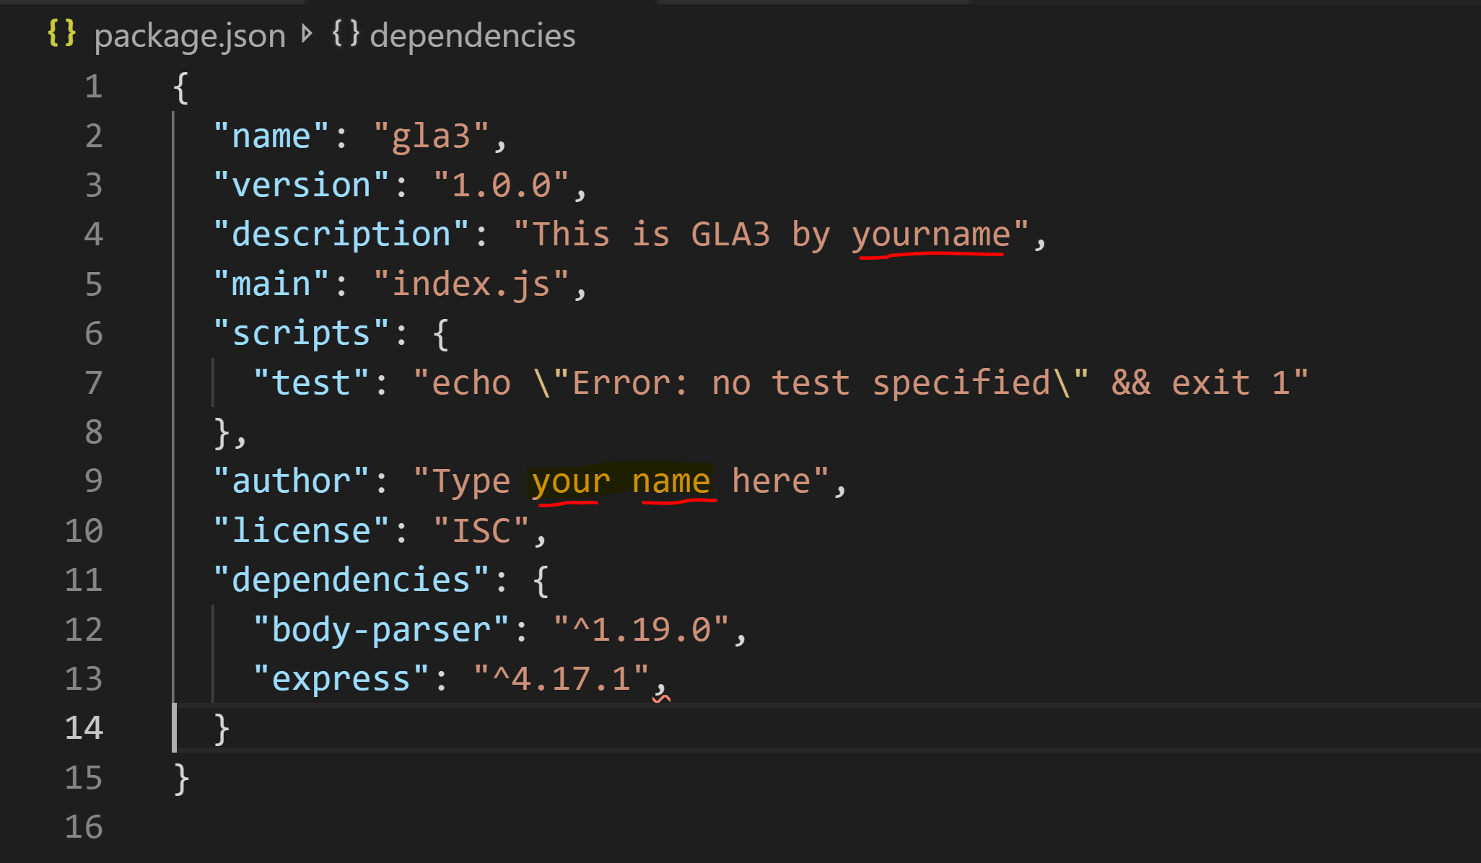

**How do you create the file shown on the above screenshot?**

Make right click in the project folder and create package.json file and copy the details

Open terminal and type node init and continue until the end by providing all the necessary details

Open terminal and type npm init and continue until the end by providing all the necessary details

Open terminal and type npm package.json and press enter by providing all the details

**The correct answer is: Open terminal and type npm init and continue until the end by providing all the necessary details.**

**What are the packages installed on the given application based on the picture above?**

Json, body-parser, fs, express

Body-parser

Express

Body-parser and express

**The correct answer is: Body-parser and express.**

**In order to install the packages shown on the picture, which command is correct syntax**

Npm install body-parser, express --save

Npm install body-parser - -save, npm install express - -save

Npm install body-parser express - - save

All are possible syntax to install multiple packages

**The correct answer is: Npm install body-parser express - - save.**

After you install and setup your project you have the following node project setup.

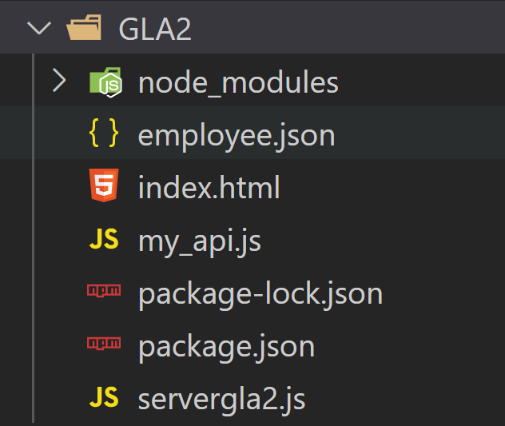

**In which file do you have to define the server setting to listen specific port?**

Inside my_api.js file and the include this file in servergla2.js

Inside servergla2.js file then include this file in my_api.js

Inside servergla2.js file and the include my_api.js file in servergla2.js file

All of them are possible ways to define the server

**The correct answer is: Inside servergla2.js file and the include my_api.js file in servergla2.js file**

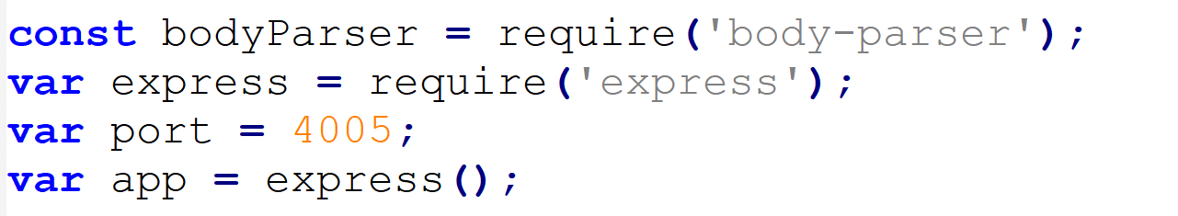

**Which one is the correct expression to include the api file in the server file?**

app.use('/', require('./my_api')());

app.use('/servergla2', require('./my_api')());

app.use('/', require('my_api')());

app.use('/', require('/my_api'));

**The correct answer is: app.use('/', require('./my_api')());**

**You have the following js object and you would like to save it to file. You are given the following code. What is wrong with the given code and what will you correct?**

{Company:"BVC", type:"college", location:"calgary", ownedby:"public", program: "daytime"}

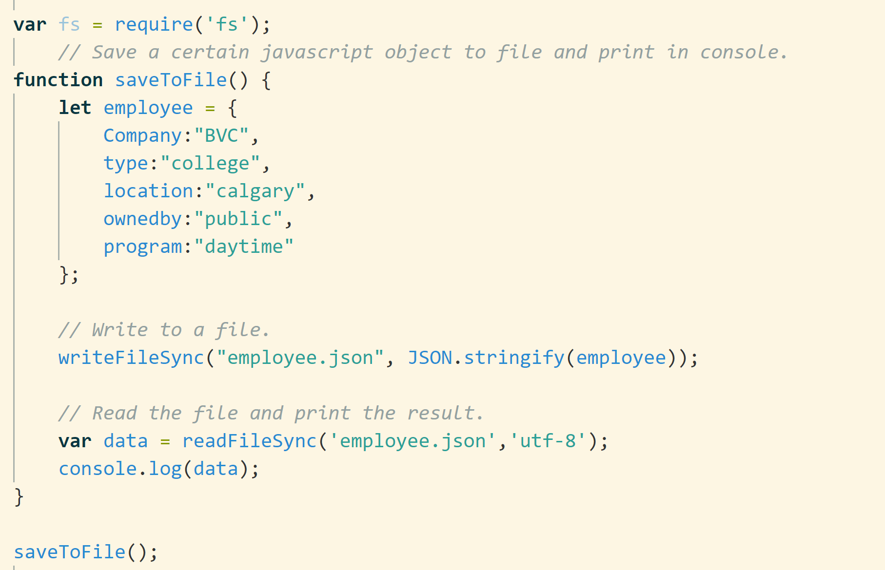

1. fs module should be declared at the very top of the application
2. fs variable should be used wherever the file system functions are used
3. there is no error with the code and it works well
4. the above code should be with in rest api to return an output

**The correct answer is: fs variable should be used wherever the file system functions are used. For fix the error, we can put that: fs.writeFileSync("employee.json", JSON.stringify(employee));**

**Inside the index.html form you have the following code. By reading the method and the action which of the following api definition is correct?**

